**DA0**

**Part b)** Determine the execution time/#cycles of your algorithm using the simulation, set

CLOCK speed = 8 MHz.

2048 us/16384 cycles = 125 ns

**Code for addition resulting in overflow:**

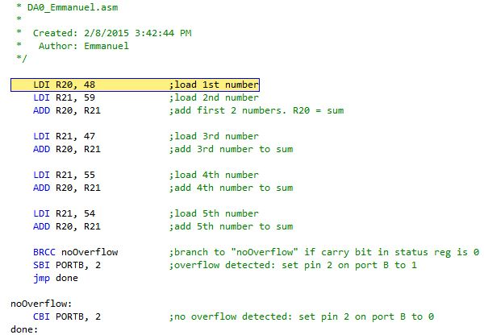

**Total sum = 263 > 255 (overflow)**

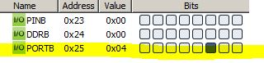

**🡨***PORTB PIN2 SET*

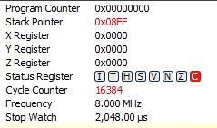

**C:\Users\Emmanuel\Desktop\CPE301\DA0\DA0 regs overflow.JPG**

🡨 Carry bit set

**Code for addition not resulting in overflow:**

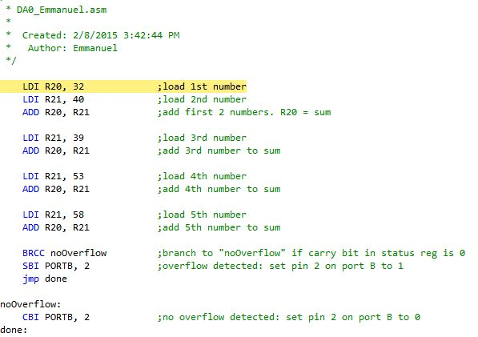

**Total sum = 222 < 255 (no overflow)**

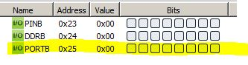

**🡨**PORTB PIN 2 NOT SET

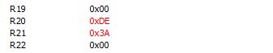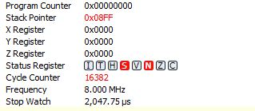

🡨 Carry bit not set